FM Receiver Module Wireless Frequency Modulation FM Radio Receiving Board DIY Digital Storage

Product Introduction;
1.Operating Voltage:3-5.5V
2.IO Voltage:-0.3~5.5V
3.RF Input Votlage:0.3V
4.Operating Temperature;-20~70 Celsius
5.Storage Temperature:-30~80 Celsius
Features:
1.Adopt DSP And PLL Technique
2.LCD Display
3.Full Digitalization Control
4.Built-In DSP Digital Silencing Processor
5.30 Levels Digital Volume Adjustment Range
6.Support Serial Port Communication Control
7.Independent Stereo/mono Control
8.Unique Silencing Signal Output Terminal
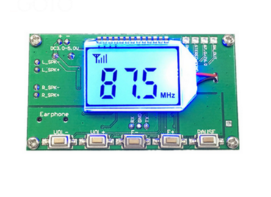
Introduction

FM_RADIO_SN is a squelch function FM radio receiver board, board integrated high sensitivity radio chip, DSP audio signal processing module, audio power amplifier, LCD display circuit, is a complete high sensitivity digital FM radio module.

一、characteristics and advantages

The radio board has the following characteristics:

1: the use of advanced digital audio signal processing technology (DSP) and phase locked loop (PLL) demodulation technology to make the sound quality more realistic, more stable performance.

The 2:LCD display is intuitive and accurate, with very low power consumption and minimal noise interference.

3: full digital control, easy to operate at the same time make the product more stable and durable.

4: built-in DSP digital squelch processor, no automatic mute signal, get rid of the traditional FM radio irritability rustle.

The range of the digital volume adjustment at the 5:30 level.

6: support serial communication control, the use of computer or MCU and other devices with TTL serial port to replace the full function of the key remote control module.

7: independent Stereo/mono control, with a stronger ability to adapt to the environment.

8: the squelch signal output terminal characteristic, can be extended to the squelch signal to control external devices.

Two, specifications and parameters

1: limit parameters

parameters minimum reference value maximum unit

temperature -20 25 +70 ℃

Storage temperature -30 25 +80 ℃

Working voltage 3.0 5.0 5.5 V

IO voltage -0.3 5.5 V

RF input voltage 0.3 V

三、product introduction

Product picture real beat

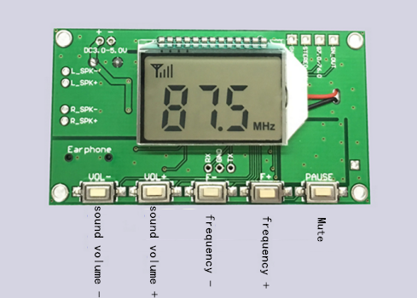
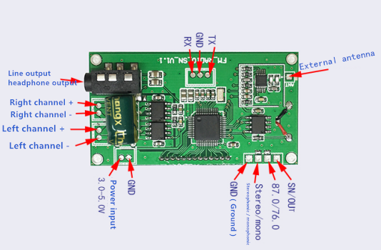
Line connection
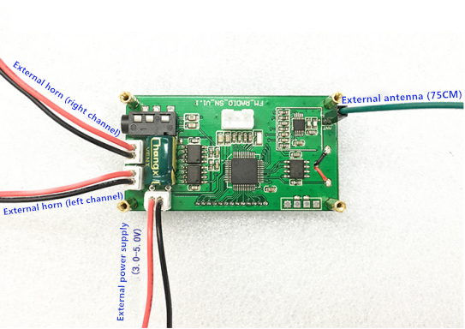

- Selection of peripheral devices
(1): the choice of power supply

<1>: FM radio is radio interference from nearby sensitive equipment, may affect the effect of radio receiver, such as microwave ovens, near the high frequency welding, or high power motor are likely to interfere with normal work and radio reception.

<2>: module power input port (PCB board marked with DC3.0-5.0V) - +, then connect the negative pole and the positive pole of the power supply (battery or regulated power supply).

<3>: the power supply voltage is required to be between the 3.0V-5.0V voltage, the maximum current is 2A or above, and the output ripple is small.

<4>: it is suggested that the power supply of lithium battery battery or power frequency transformer is obtained after rectification and filtering. Switch power without filters, such as cell phone charger and rechargeable battery, can not be used. First, the switching process of this kind of power will generate a lot of high-frequency interference, which directly affects the reception effect of radio. The two is the charger of mobile phone. The output voltage of charging treasure tends to be higher than the working voltage of module 5V, so it is easy to burn out module in long-term work. It is not recommended to the USB power supply from the computer, because the computer USB power supply current is limited, the above modules work in a large volume of state current up to 1A, long-term work will make the computer USB power supply damage or protection, in addition to the power of USB comes from the computer which contains a variety of high frequency interference EEG working process. Will affect the effect of radio.
(2): selection of loudspeakers
<1>: suggested the use of a pair of speakers with 4 /3W or 4 /5W, the best efficiency in order to achieve the output of a power amplifier.
<2>:SP_L left horn, SP_R right speaker, the anode and the cathode are respectively connected with the corresponding SP+/SP- horn.
<3>: if it is to be driven directly by 3.5mm headset, headset plug insert audio board seat, insert the headset, the power amplifier output will automatically shut down.
(3): the selection of antenna

<1>: antenna is mainly responsible for receiving radio waves from space, according to the selection rules of the antenna, the antenna length as close as possible to the 1/4 wavelength of the received frequency, such as the 100MHz receiver to the radio antenna, the ideal length is L= (velocity / frequency) /4=300000000/100000000=75cm.

<2>: the FM special radio antenna using a 75 cm length.

五、 Key operation instructions

(1): volume regulation

V- button: short press the volume -, press the continuous -

V+ button: short press the volume + ， continuous press +

(2): frequency regulation

CH model:

F- key: short press channel -, according to a long search platform

F+ key: short press channel +, press down search

FRE model:

F- key: short press frequency -0.1MHz, according to the frequency of long continuous -1MHz

F+ key: short press frequency +0.1MHz, according to the frequency of long continuous +1MHz

(3): Mute / play

PAUSE key: short press the mute / play, press the full band automatic search and save the radio (CH mode).

(4): automatic squelch threshold (threshold) set

And press the F-/F+ button for 2 seconds, into the automatic squelch threshold adjustment interface, the user can adjust the threshold according to the use of automatic squelch action of the adjustment range of t00-t20 value is higher, the gate limit, weak signal value is more likely to be mute, door limit is low, the weak signal is more difficult to be mute. General can be adjusted within the range of t02-t05, t=00 to turn off automatic squelch function.

<5>: backlight setting

When the power is down, press the PAUSE button and then go on and continue to press. LCD shows the "HI" interface and then shows "B1", which indicates that the backlight has been set to the constant brightness mode. The display "B0" indicates that the backlight has been set as the power saving mode, and there is no key operation of the 20s backlight to automatically extinguish under the power saving mode. After setting up, power needs to be broken and reconnected. Change the set state to repeat this step to switch (the factory default is B0 or backlight power saving mode).

<6>:CH/FRE mode switching

At the same time, when the VOL-/VOL+ knob is pressed for 2 seconds, the LCD displays the CH representation of the switch to the search storage mode, showing that the FRE is switched to the manual setting frequency mode. CH mode F-/F+ key to channel + / - function , FRE mode F+/F- key to the frequency +/-function.

六、external terminal instructions

<1>: earphone (audio output) terminal

Earphone (audio output) terminal is used to connect earphone or output as audio signal to connect external audio power amplifier. The standard 3.5mm stereo audio stand is adopted. When the terminal is inserted into the audio, audio detection a foot on the ground short circuit, micro controller detects signals automatically switch to the audio output mode, the output is off board power amplifier, the output amplitude adjustment of DAC at the same time to promote a headset or driving an external power amplifier standard.

<2>: power amplifier output terminal

The module board integrated 3Wx2 power amplifier, speakers can directly drive two 3W

Corresponding SP_L port is connected with the left channel loudspeaker, corresponding to the SP_R port is connected with the right channel loudspeaker, wherein SP+/SP- is a positive and negative pole speaker.

<3>:Stereo (stereo) /mono (single channel) switch terminal

Stereo/mono terminal module used to set the FM receiving mode, the terminal is suspended for stereo reception mode, the terminal of the receiving mode for single channel.

Explain：

The purpose of setting Stereo/mono switch is: because of the difference between stereo decoding and mono channel decoding, decoding stereo signal occupies a wider frequency band and requires higher signal quality. Therefore, when listening to relatively weak stereo broadcasting, the signal to noise ratio will be very low, which will produce a lot of bottom noise. At this time, the circuit can be changed to a single channel receiving state to improve the signal to noise ratio of the output signal. Although there is no stereophonic effect in the monophonic mode, the noise is relatively small, but it makes the listening effect better. In other words, this is to switch in the weak signal environment is used to improve the signal-to-noise ratio of the radio, switch to mono, can make the radio in the weak signal under the condition of sound is relatively clear, so in the high-end FM stereo radio are reserved for Stereo/mono switch to achieve a more strong ability to adapt to the environment.

<4>:87.0/76.0 (campus broadcast band settings)

87.0/76.0 terminal module is used to set the open campus radio frequency mode, the terminal is suspended for off campus broadcast mode (frequency range is 87.0-108.0MHz), the terminal of on campus broadcasting mode (frequency range 76.0-108.0MHz).

<5>:SN_OUT (static signal output terminal)

Set the terminal applications need to reserve the squelch signal to the external trigger may, when the squelch function module on the terminal output function. When internal squelch action output high level output low level, no action. Note that the output capacity of this terminal is 3.3V/20mA.

<6>: external antenna terminal

FM_ANT terminal antenna signal input terminal FM radio antenna, the signal from the input. A short wire can be connected to the external FM pull rod antenna.

<7>:UART terminal

Connect the TTL serial port for UART terminal, can through the computer serial port (USB TTL serial line), serial port and TTL module MCU or other controllers are connected, each function through serial command control module, can replace the key operation, or remote control (please refer to the specific serial control port manual document).

